

Informatics
Practices
Project

Topic : E-commerce Application
Project By : Manish Gupta
Class : XII – B
Guided By : Mr. Vasi Sir
Board Roll No. :
CERTIFICATE

This is to certify that Manish Gupta, student of class XII-B has successfully completed the Informatics Practices Project under the guidance of Mr. Vasi Sir. This project is genuine and is not plagiarism of any kind. The references used in making this project file are declared at the end of the file.

Teacher’s Sign Principal’s Sign
(With School’s Stamp)

INDEX

S.No. | Contents | Pg. No.
1 | Acknowledgement | 4
2 | Introduction | 5
3 | Pesa Charge(The App) | 3-11
4 | Pesa Charge(Tables) | 12
5 | Pesa Charge(Code) | 13-20
6 | Bibliography | 21

ACKNOWLEDGEMENT

I wish to express my deep gratitude and sincere thanks to the Principal, Mr. N.K. Tiwari, Greenwood Senior Secondary School, Rampur for his encouragement and for all the facilities he has provided for this project work.
I extend my hearty thanks to my subject teacher Mr. Vasi Sir who guided me to the successful completion of this project. I take this opportunity to express my deep sense of gratitude for their invaluable guidance, constant encouragement and immense motivation which has sustained my efforts at all stages of this project work. I can’t forget to offer my sincere thanks to my classmates who helped me to carry out this project work successfully and for their valuable advice and support which I received from them time to time.

INTRODUCTION

E-commerce applications have become essential these days. They play a crucial role in one’s life. Due to such apps, the work is completed at an efficient rate. Also, wasting time at shops waiting for your turn seems an old fashion and leads to wastage of your precious time. Here comes the ultimate solution to all your dilemmas.

Pesa Charge is an E-commerce application which helps you to recharge your Mobiles, DTH on the go. This App is user friendly.
Thus, Mobile and DTH recharges have become much more easier.

The App Consists of Five main Windows:-

- Login
- Registration
- Mobile Recharge
- DTH Recharge
- Redressal

PESA CHARGE
THE APP

- LOGIN WINDOW :

This is the default window of the application. It pops up as soon as the user runs the app. It asks the user for his/her credentials. After entering correct details in the application, this window redirects the user to Mobile recharge window.
It consists of A Tabbed Pane, A Panel, TextFields, Labels and Buttons.
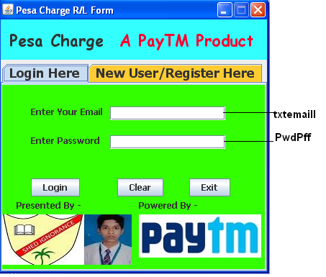

- REGISTRATION WINDOW :

This is the Registration window of the application. It allows the User to register him/her on the app and allows him/her to use it further. It asks the user for his/her details. After entering all the required details, this window pops out a message on successful completion or gives an error if the user is registered already.
It consists of A Tabbed Pane, A Panel, TextFields, Labels and Buttons.

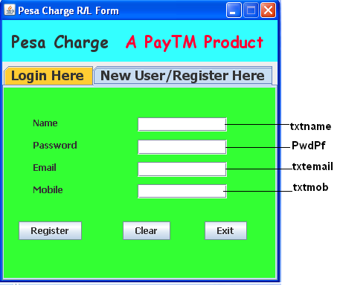

Note:- This window inserts the details in table Reg of database pesacharge created in MySql. The database and its tables will be described later.

- MOBILE RECHARGE WINDOW :

This is the Mobile Recharge window of the application. It pops up as soon as the user hits login button after entering correct details in login window. It allows the User to recharge his/her mobile. After entering all the required details, this window pops out a message on successful recharge or gives an error if the user has recharged with same amount on that day for the same number.
It consists of A Tabbed Pane, A Panel, TextFields, Radio Buttons, Labels and Buttons.

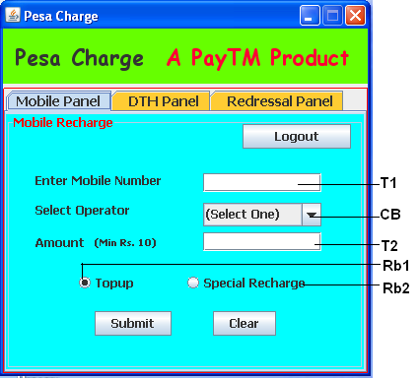
Note:- This window inserts the details in table MobRech of database pesacharge created in MySql. The database and its tables will be described later.

- DTH RECHARGE WINDOW :

This is the DTH Recharge window of the application. It appears on successful login. It allows the User to recharge his/her DTH card. After entering all the required details, this window pops out a message on successful recharge or gives an error if the user has recharged with same amount on that day for the same Customer ID.
It consists of A Tabbed Pane, A Panel, TextFields, Labels and Buttons.

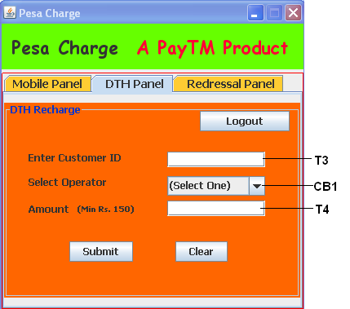
Note:- This window inserts the details in table DthRech of database pesacharge created in MySql. The database and its tables will be described later.

- REDRESSAL WINDOW :

This is the Recharge Redressal window of the application. It appears on successful login. It allows the User to check the recharge of his/her Mobile/DTH card. After entering all the required details, this window pops out a message of Successful past recharge or gives an error if the record doesn’t exists in the database.
It consists of A Tabbed Pane, A Panel, TextFields, Radio Buttons, Labels and Buttons.

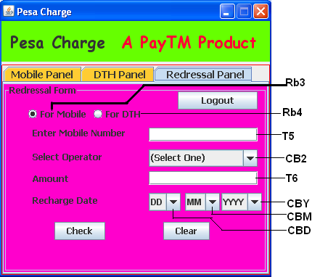

Note:- This window retrives the data from tables DthRech and MobRech of database pesacharge created in MySql. The database and its tables will be described later.

Must Read before You use the App:

- That on Clicking Logout Button, the current form is disposed and the Login form Reopens.
- That in the login form, if no action takes place on entering details, this means that either you’ve entered invalid email id or your account does’nt exists.
- That if an error occur while recharging, this means you are recharging on the same number once again with the same amount on the same date which is absurd in Pesa Charge.

(Contd.)

THE TABLES

The app Pesa Charge is connected with a MySql Database pesacharge and therefore, retrives and inserts data into its tables accordingly.

The Database has three tables:

- MobRech (For Storing & Retrieving Mobile Recharges)
- DthRech (For Storing & Retrieving DTH Recharges)
- Reg (For Storing & Retrieving Registration Details)

The Table MobRech is accessed via Mobile Recharge and Redressal Windows.

The Table DthRech is accessed via DTH Recharge and Redressal Windows.

The Table Reg is accessed via Login and Registration Windows.

These tables are using only Primary Key and Not Null Constraints.

THE SOURCE CODE

Pesa Charge uses its main class Main.java
The Code used in this Class is :

package pesacharge1;

/**
*
* @author Manish Gupta
*/
public class Main {

/**
* @param args the command line arguments
*/
public static void main(String[] args) {
RegForm Object = new RegForm();
Object.setVisible(true);
Object.setDefaultCloseOperation(RegForm.EXIT_ON_CLOSE);
// TODO code application logic here
}

}

Pesa Charge uses an additional class Database.java
which is used to establish connectivity between java and MySql
The Code used in this Class is:

package pesacharge1;

import java.sql.*;
import javax.swing.JOptionPane;
/*
* To change this template, choose Tools | Templates
* and open the template in the editor.
*/

/**
*
* @author Manish Gupta
*/
public class Database {
public Connection conn = null;
public Statement stmt = null;
public ResultSet rs = null;
public Date date11 = null;

public void connect(){
try{Class.forName("com.mysql.jdbc.Driver");
conn = DriverManager.getConnection("jdbc:mysql://localhost:3306/PesaCharge", "root", "aa");
stmt = conn.createStatement();
}
catch(Exception e){
JOptionPane.showMessageDialog(null,"Error In Connectivity = "+e);
}
}

}

Login Window Codes:

- For Login Button :

Database obj = new Database();
obj.connect();
String Id = txtemaill.getText();
String Pass = new String(PwdPff.getPassword());
try{
String sql = "Select Email, password, Name from Reg Where Email = '"+Id+"';";
obj.connect();
obj.rs = obj.stmt.executeQuery(sql);
while (obj.rs.next()){
String email = obj.rs.getString("Email");
String pwd = obj.rs.getString("password");
String Name = obj.rs.getString("Name");
if(email.equalsIgnoreCase(Id) && pwd.equalsIgnoreCase(Pass))
{
JOptionPane.showMessageDialog(null, "Welcome, "+" "+Name);
dispose();
PesaChargeMain objj = new PesaChargeMain();
objj.setVisible(true);
objj.setDefaultCloseOperation(PesaChargeMain.HIDE_ON_CLOSE);
}
else{JOptionPane.showMessageDialog(null, "Invalid Credentials");}}
}
catch(Exception e){
JOptionPane.showMessageDialog(null, "Invalid Credentials = "+e);
}

- For Clear Button:

txtemaill.setText(null);
PwdPff.setText(null);

- For Exit Button :

System.exit(0);

Registration Window Codes:

- For Register Button:

Database obj = new Database();
obj.connect();
String name = txtname.getText();
String pwd = new String(PwdPf.getPassword());
String Email = txtemail.getText();
long mob = Long.parseLong(txtmob.getText());

try {
String sql = "Insert into Reg Values('"+name+"', '"+pwd+"', '"+Email+"', "+mob+");";
obj.connect();
obj.stmt.executeUpdate(sql);
JOptionPane.showMessageDialog(null, "Succesfully Registered");

} catch (Exception e) {
JOptionPane.showMessageDialog(null, "Already Exists");

}

- For Clear Button:

txtname.setText(null);
PwdPf.setText(null);
txtemail.setText(null);
txtmob.setText(null);

- For Exit Button:

System.exit(0);

Mobile Recharge Window Codes:
- For Submit Button:

Database obj = new Database();
obj.connect();
String mob = T1.getText();
long mob1 = Long.parseLong(mob);
String Op = (String) CB.getSelectedItem();
String Amt = T2.getText();
int Amt1 = Integer.parseInt(Amt);
String Type;
if (Rb1.isSelected()) {
Type = "Topup";
} else {
Type = "Special";
}
try{
String sql = "Insert Into MobRech Values(" + mob1 + ", '" + Op + "'," + Amt1 + ",'" + Type + "', Curdate());";
obj.connect();
obj.stmt.executeUpdate(sql);
{JOptionPane.showMessageDialog(null, "Succesfully Recharged");}
}
catch (Exception e){
JOptionPane.showMessageDialog(null, "Error in Recharge = "+e);}

- For Clear Button:

T1.setText(null);
T2.setText(null);
CB.setSelectedIndex(0);
Rb.clearSelection();
Rb1.setSelected(true);

DTH Recharge Window Codes:
- For Submit Button:

Database obj = new Database();
obj.connect();
String dthid = T3.getText();
long cid = Long.parseLong(dthid);
String Op = (String) CB1.getSelectedItem();
String Amt = T4.getText();
int Amt1 = Integer.parseInt(Amt);
try{
String sql = "Insert Into DthRech Values(" + cid + ", '" + Op + "'," + Amt1+", Curdate());";
obj.connect();
obj.stmt.executeUpdate(sql);
{JOptionPane.showMessageDialog(null, "Succesfully Recharged");}
}
catch (Exception e){
JOptionPane.showMessageDialog(null, "Error in Recharge = "+e);}

- For Clear Button:

T3.setText(null);
T4.setText(null);
CB1.setSelectedIndex(0);

- For Logout Button: (Please note that this button is common in 3 Windows)

dispose();
RegForm object = new RegForm();
object.setVisible(true);
object.setDefaultCloseOperation(RegForm.HIDE_ON_CLOSE);

Redressal Window Codes:
- For Check Button:

Database obj = new Database();
obj.connect();
long no = Long.parseLong(T5.getText());
String Oper = (String) CB2.getSelectedItem();
String d = (String) CBD.getSelectedItem();
String m = (String) CBM.getSelectedItem();
String y = (String) CBY.getSelectedItem();
int day = Integer.parseInt(d);
int month = Integer.parseInt(m);
int year = Integer.parseInt(y);
String date = year+"-"+month+"-"+day;
java.sql.Date dmy = java.sql.Date.valueOf(date);
int Amt = Integer.parseInt(T6.getText());
String bool;
if (Rb3.isSelected()){
try {
String sql = "Select * from MobRech where Number = "+no+" And Date = '"+dmy+"' And amount ="+Amt+";";
obj.connect();
obj.rs = obj.stmt.executeQuery(sql);
while(obj.rs.next()){
String Opr = obj.rs.getString("Operator");
int a;
a = Opr.length();
if(a>0){
bool = "Succesfull";
JOptionPane.showMessageDialog(null, "Your Recharge for "+Opr+" was "+bool);
}
else{
bool = "Failed";
JOptionPane.showMessageDialog(null, "Your Recharge for "+Opr+" was "+bool);
}
}

} catch (Exception e) {
JOptionPane.showMessageDialog(null, "Error in Connectivity = "+e);
}

}

else {
try {
String sql = "Select * from DthRech where C_ID = "+no+" And Date = '"+dmy+"' And amount ="+Amt+";";
obj.connect();
obj.rs = obj.stmt.executeQuery(sql);
while(obj.rs.next()){
String Opr = obj.rs.getString("Operator");
int a;
a = Opr.length();
if(a>0){
bool = "Succesfull";
JOptionPane.showMessageDialog(null, "Your Recharge for "+Opr+" was "+bool);
}
else{
bool = "Failed";
JOptionPane.showMessageDialog(null, "Your Recharge for "+Opr+" was "+bool);
}
}

} catch (Exception e) {
JOptionPane.showMessageDialog(null, "Error in Connectivity = "+e);
}

}

- For Clear Button:

T5.setText(null);
T6.setText(null);
Rbr.clearSelection();
Rb3.setSelected(true);
L10.setText("Enter Mobile Number");
CB2.setModel(new javax.swing.DefaultComboBoxModel(new String[] { "(Select One)", "Aircel", "Airtel", "BSNL", "Idea", "MTS Telecom", "Tata Docomo", "Tata Indicom", "Uninor", "Videocon", "Virgin", "Vodafone" }));

- For Radio Buttons :

- For Rb3:

L10.setText("Enter Mobile Number");
CB2.setModel(new javax.swing.DefaultComboBoxModel(new String[] { "(Select One)", "Aircel", "Airtel", "BSNL", "Idea", "MTS Telecom", "Tata Docomo", "Tata Indicom", "Uninor", "Videocon", "Virgin", "Vodafone" }));

- For Rb4:

L10.setText("Enter Customer ID");
CB2.setModel(new javax.swing.DefaultComboBoxModel(new String[] { "(Select One)", "Airtel Digital", "dishTV", "Reliance Big TV", "Sun Direct", "Tata Sky", "Videocon d2h" }));

Code for Events used in various controls:
Focus Lost Event:
- At T1 at Mobile Recharge Window:

String txt = T1.getText();
int a = txt.length();
if (a!=10){JOptionPane.showMessageDialog(null, "Invalid Mobile Number");}

- At T2 at Mobile Recharge Window:

String txt = T2.getText();
long a = Long.parseLong(txt);
if (a<10){JOptionPane.showMessageDialog(null, "Invalid Amount Entered");}

- At T4 at DTH Recharge Window:

String txt = T4.getText();
long a = Long.parseLong(txt);
if (a<150){JOptionPane.showMessageDialog(null, "Invalid Amount Entered");}

BIBLIOGRAPHY

Informatics Practices Textbook for Class 12
By :Sumita Arora
Subject teacher
Mr. Vasi Sir
Websites
www.icbse.com
www.cbsecsnip.com
www.cbseipprojects.com

End of Project Report


